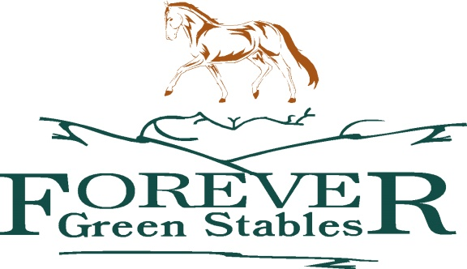
OSPCA Stories.
“Shilo”
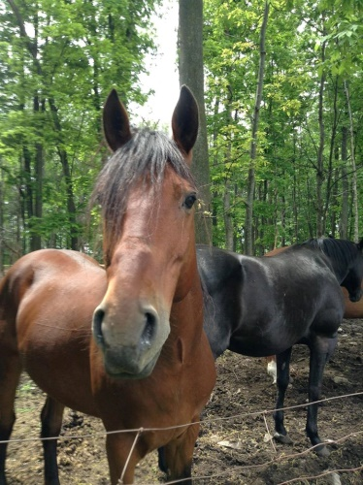
. He needed to learn how to walk , move and be a horse before he could learn how to be a riding or driving horse.

OSPCA was called in for a down horse. Assessment was done, mare was older, owner was elderly and decision for euthanasia was made. I believe the older gentlemen was a kind man but had perhaps an old mind set when it came to animals. More of a means to an end rather than a pet or animal which needed more hands on care. While the OSPCA agent was there he pointed out that he had 3 others horses in the barn. The agent went in and wow! 3 stallions, in the darkest of dark barns, no windows. They were father and two sons, mare outside was their mother. All 3 were seized as they were in terrible condition. Stalls were never cleaned and animals never saw daylight, food and water was intermittent. All three were knee deep in feces and terribly terribly thin. All three were to be moved down the street in order to be helped more easily; sadly dad found the stress too hard and he passed away. Shilo and his brother were being treated in order to stabilize them to go to “rescue barn” for proper rehabilitation and rehoming. Sadly Shilo’s brother passed away as his system was just too far gone.
Shilo moved to ”rescue barn” Forever Green Stables and was named Buddy . He was assessed to be a 7 year old morgan stallion. His feet were in terrible condition and he was skin and bones. He has spent these 7 years of his life in a dark barn with no exercise or turn out at all. His joints stiff and swollen he had to learn to walk at Forever Green Stables where he recovered from the trauma of his past life. He was gelded and turned out on free choice hay, minerals and feet trimmed
Despite all the cruelty and suffering he must of endured he remained a sweet, gentle little horse with a gentle eye and a will to please.
The Lightstone’s first heard of him after they sadly lost one of their other rescues to colic. Concerned for a grieving partner they wanted to find another rescue . When they heard Shilo’s story they were intrigued and then amazed by this gentle little horse. They fell in love at first sight and shortly thereafter, he arrived to join a motley herd of other rescues. The old racehorse, Oscar he had initially been adopted to cheer up , liked him right away . The old mare, Poe, fell desperately in love with him. The four miniature donkeys were intrigued too, and soon found him an admirable playmate.
A month later another horse Lexington, of a similar age, joined the herd and a close friendship soon ensued. With Lexington , Shilo ( renamed, as he was shy and ‘low’ compared to the other horses!) learned to play, prance and gallop around like a stallion ( which he was no longer!) He was learning to be a horse and how to function in a herd. During the summer months his herd joined the neighbours 4 horse herd and Shilo had to learn what it was to be the outcaste as the extra, junior stallion. That was a hard lesson for him but true to his nature he remained calm, and pleasant with his lot in life and stole the other gelding’s mares whenever he wasn’t looking with a broad grin on his face!
In the past 5 years we have watched Shilo learn to be a leader with our herd, protect Oscar and Poe as the seniors, organize the donkeys who are a very wilfull bunch and keep the ever playful and often greedy Lexington in check.
He loves people and attention and will stand and lean for a chest and neck rub. He still has much to learn about being lead and finally ridden but he has learned so much in the past 5 years about how to be just a horse , that we are content to go slowly.
